|  |
| --- |
|  |
| BIFROST AVS Vacuum tank MOTION SAT |
|  |

|  | Name | Role/Title |
| --- | --- | --- |
| Owner | Anders Sandström | Electronics Engineer Motion Control & Automation |
| Reviewer | Thomas Gahl | Group Leader Motion Control & Automation |
| Approver | Liam Whitelegg | Instrument Lead Engineer for BIFROST |

TABLE OF CONTENT PAGE

1. Background 4

1.1. Equipment in scope 4

2. Requirements 4

3. CONTROL SYSTEM 4

3.1. Hardware 5

3.2. EL7037 Stepper drive 5

3.3. EL7201 Resolver interface 5

3.4. Feedback systems 5

3.4.1. Laser triangulation sensor Micro Epsilon ILD2300 5

3.4.2. Resolver, AMCI R11X-J10/N 5

4. METHOD 7

4.1. General Inspection 8

4.1.1. Mechanical 8

4.1.2. Electrical 8

4.2. Motion Tests 8

4.2.1. Initial Motion Test 8

4.2.2. Repeatability 9

4.2.3. Accuracy 9

4.2.4. Switch Performance 9

4.2.5. Resolver Performance 9

4.2.6. Data Acquisition 9

4.3. Presentation of results 10

4.1. Analysis 10

5. Results 11

5.1. 11358 Axis 1 11

5.2. 11358 Axis 2 12

5.3. 11359 Axis 1 14

5.4. 11359 Axis 2 16

5.5. 11360 Axis 1 17

5.6. 11360 Axis 2 18

5.7. 11361 Axis 1 19

5.1. 11361 Axis 2 20

6. CONCLUSIONS 21

7. references 22

8. Appendix A Micro Epsilon ILD2300 Calibration REPORT 23

list of tables

Table 1:Status 10

Table 2: Results 11358, axis 1 11

Table 4: Results 11358, axis 2 12

Table 5: Results 11359, axis 1 14

Table 6: Results 11359, axis 2 16

Table 7: Results 11360, axis 1 17

Table 8: Results 11360, axis 2 18

Table 9: Results 11361, axis 1 19

Table 10: Results 11361, axis 2 20

list of Figures

Figure 1: JJ X-RAY: Slit set 4

Figure 2: Test setup 7

Figure 3: Bent levers of limit switches 13

Figure 4: Bent limit switch lever 15

# Background

The instrument consists of three main technical subsystems: the beam transport and conditioning system (BTS), the sample exposure system (SES) and the scattering characterization system (SCS). The whole system allows the measurement of collective dynamics in crystalline systems in the field of materials science, optimized for neutron flux and sample environment performance. Bifrost’s scattering characterization system consists of the filtering system and the secondary spectrometer vessel. The secondary spectrometer vessel houses the analysers, the detectors and the crosstalk shielding between energy-and Q-channels.

## Equipment in scope

The spectrometer vessel is a 2m x 3.5m aluminum vacuum tank. It will be mounted on a rail system so that it can rotate in the horizontal plane. It shall be positioned, with respect to a rotation around the sample vertical axis, with a ground mounted system. The rail and carriage system shall keep the tank’s rotation concentric to the sample axis, a stepper motor shall provide the drive whilst a rotary encoder shall provide positional feedback. The drive system employs a secondary axis that exerts a force in the opposite direction to the drive in order to minimise the backlash of the system.

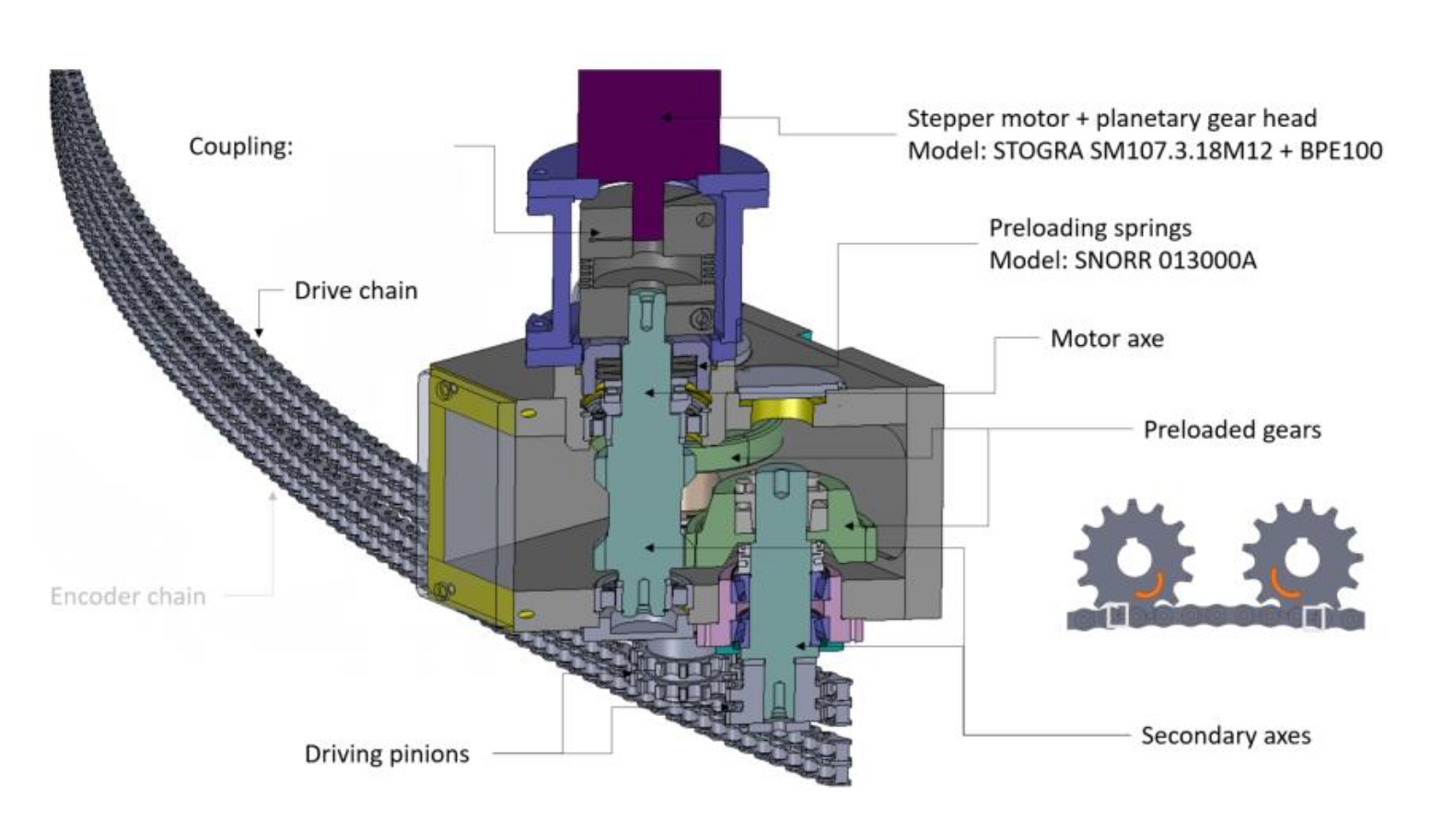

Figure 1: Tank motion system overview.

Spectrometer vessel motion components:

* Stepper motor: Stögra SM107.3.18M12+BPE100 (w/gear ratio of 100) REFERENCE
* SSI Encoder: Posital OCD-S101G-1416-S060-PRL REFERENCE
* Limit switches: Crouzet 83 871 306
* Stroke: Approx. 50 degrees
* Gear ratio: 12382 (according to manufacturer AVS) REFERENCE

# Requirements

The following requirements, as defined in ESS-1088870, were verified in this SAT:

Table 1: Requirements

|  |  |
| --- | --- |
| Requirements | Value |
| Accuracy | 0.1 deg |
| Repeatability | 0.05 deg |
| Range | Central axis to rotate from -4.5 degrees through to 45.5 degrees (0 degrees is perpendicular to the sample position) |
| Velocity | 0.1 deg/s ---> 1240 degmotor/s (gear ratio 12382) |
| Accelerations | 410 degmotor/s2 (stop from max speed in 3 seconds) |
| Travel time | The assembly shall travel through the range of motion within 15 minutes (688 degmotor/s) |
| Switching Positions | Switches S1 to S5 according to figure below +-0.1deg |
| Motor current | 10 ARMS |

# CONTROL SYSTEM

The SAT was performed with an EtherCAT [1] based control system, ecmc [2]. The configuration files, raw data and analysis results for the SAT have been added to a git repository [3]REFERENCE.

All hardware needed for the tests have been integrated into the same system which then leads to that all sampled data have the same time base.

## Hardware

The following control hardware was used:REFERENCES

1. iPOS8020 BX-CAT: Stepper motor drive [4]
2. EL1004: Digital input for switches [5]
3. EL2808: Digital output to feed switches [6]
4. EL5002: SSI Absolute Encoder interface [7]
5. Laser tracker:

## iPOS8020 BX-CAT Stepper drive

The stepper drive was configured to control the specific system as show below:

1. Control mode: Open loop
2. Run current: 10A
3. Standby current: 1A
4. Micro stepping: 256 fold (resolution 51200 steps/rev for the 200 steps motor)
5. Velocity: 688 deg motor/s CONVERT VALUE TO DEGREES

## EL5002 SSI Absolute Encoder Interface

The EL5002 delivers a single turn resolution up to 32bits. Frame size 31 data length 31? For this system 31 bits were used.

## Feedback systems

Two different sensors are used as position feedback for the tests.

1. ILD2300 : Micro Epsilon Laser triangulation sensor [9].
2. SSI Absolute Encoder : Posital OCD-S101G-1416-S060-PRL Reference

### Laser triangulation sensor Micro Epsilon ILD2300

The Micro Epsilon ILD2300 sensor was used as external measurement and verification system. The ILD2300 have the following specs:

1. Range: 50mm
2. Linearity: +-10 μm (protocol: Appendix A Micro Epsilon ILD2300 Calibration)
3. Resolution: 0.8 μm

This sensor can only cover parts of the approximate 70mm stroke.

### Resolver, AMCI R11X-J10/N

The AMCI resolver was delivered with the slits mounted on the second shaft of the motor. The AMCI R11X-J10/N resolver have the following specs:

1. Accuracy: 7 arcmin (0.12deg)
2. Input voltage: 7V
3. Input frequency: 5000Hz
4. Transformation ratio: 0.95+-5%

The accuracy of 7arcmin corresponds to a linear accuracy of 0.32μm.

# METHOD

As a first step, a general inspection of the vacuum tank frame mechanics from a mechanical and electrical perspective will be performed. If no issues were found during the general inspection then motion tests should be performed.

The following tests are planned to be performed:

1. *General inspection*
2. *Initial motion test*
3. *Motion range and switch performance*
4. *High speed test*
5. *Accuracy*
6. *Bidirectional repeatability*

## General Inspection

Inspection of all axis components from a mechanical and electrical perspective. The following checklists should be followed:

## General Inspection

Inspection of all axis components from a mechanical and electrical perspective.

### Mechanical

The following checklist should be followed:

* Ensure no loose components.
* Ensure no risk of collisions.
* Status of limit switches and cams.
* Ensure connectors are fixed properly (not loose)

### Electrical

Mainly tests of electrical wiring:

1. Inspection of cabling.
2. Test grounding between control box and frame of vacuum tank.
3. Measure coil resistance of stepper motor (phase A and B).
4. Measure connection of switches:
   * Limit switches
   * Kill switches
   * Anti-collision switch

## Motion Tests

The motion tests have been divided into the following parts:

1. Initial motion test
2. Repeatability
3. Accuracy
4. Switch performance
5. Resolver performance

### Initial Motion Test

Motion of the entire stroke should be tested with a low velocity. During this test special attention is on the following topics:

1. Noise from the equipment (observed and noted down).
2. Test of switch actuation of the cams, adjusted if needed.

As a last step, a homing sequence can be executed, setting the stepper open loop counter to the desired value at low limit disengage flank (0 to 1).

### Repeatability

The repeatability was measured by moving to three different target positions distributed over the stroke,

1. 15mm
2. 35mm
3. 55mm

Each target position was approached 10 times from both positive and negative direction from a 2mm offset. The repeatability for each position is represented by the largest difference between the positions achieved during the test.

### Accuracy

Accuracy was measured by moving to 12 different target position distributed over the stroke starting at 5mm increasing with 5mm up to 60mm. The test was performed in both directions.

The accuracy is represented by the largest difference between target position and the actual value achieved.

### Switch Performance

The switch performance was measured by latching positions at engage/disengage of the switch. The switches were engaged and disengaged 10 times. The switch performance is represented by position range of latched position values.

### Data Acquisition

During the motion tests (2-5) the following data was acquired:

1. Laser Scanner
2. Posital Absolute encoder
3. Stepper open loop counter position
4. Switch status

Data will be acquired with a sampling rate of 100Hz.

## Presentation of results

The results for each axis are summarized in tables. Each test, like described above, is evaluated and the status is presented in one of the following three grades:

Table 2:Status

|  |  |  |
| --- | --- | --- |
|  | **Status** | **Description** |
| **1** | OK | Test result is fulfilling requirement. |
| **2** | Check | The test / observation needs further investigation. |
| **3** | Not OK | The test / observation is not fulfilling requirement. |

All raw data and more detailed reports can be found in the following git repository:

<https://github.com/anderssandstrom/ecmc_bifrost_slits_sat/tree/master/tests>

## Analysis

Test sequence and analysis was performed/automated by python and bash scripts. The source code can be found here:

<https://github.com/anderssandstrom/ecmccomgui/tree/master/tools>

# Results

In general, the tests went well until the test when measuring the total motion range. When approaching the upper hard limit, the tank collided with the center concrete block. Most tests were already dine before the collision but some extra data was collected in order to see if the collision had any impact on the performance of the movement. A comparison can be found in chapter 6.

## General inspection

Vacuum equipment was found to be connected and prevented motion. Disconnected.

## Initial motion test

### Switches

All switches except the anti-collision switch was found to be engaging properly. The anti-collision switch was therefore adjusted.

### Gear ratio

Basic gear ratios were calculated for both encoder and motor.

Gear ratio motor: 8,10165*10-5degtank/degmotor

Gear ratio encoder: 4.43610-5degtank/countsencoder

These gear ratios were used to generate setpoints for the further tests.

For analysis of the data, gear ratios calculated from the accuracy test are used.

### Backlash

A simple backlash tests was performed at approx. -10deg (only at one position). The test measures only the backlash between encoder and motor shaft.

Figure 2 shows a graph for the backlash test in forward direction and Figure 3 shows the backlash test in backward direction.

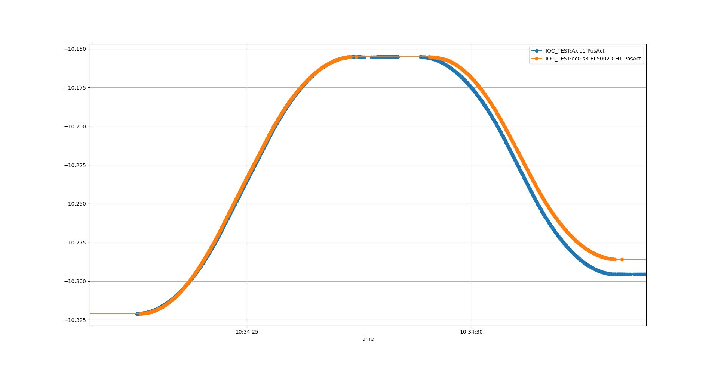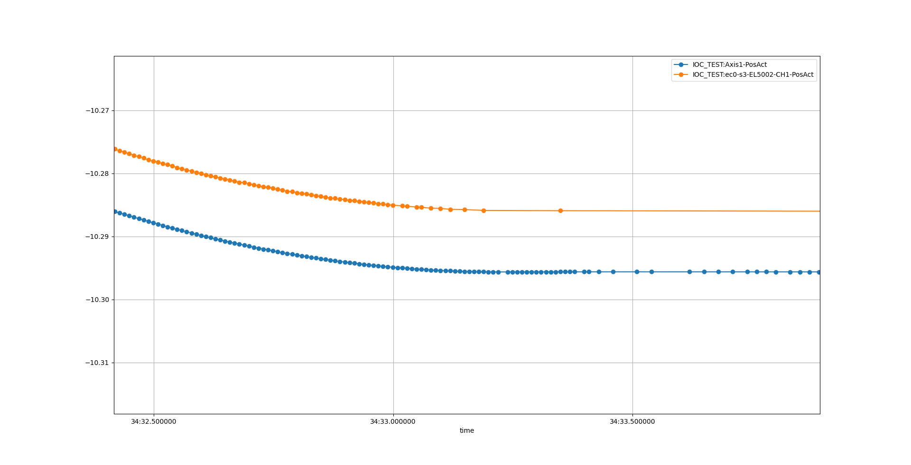

Tank angle

Time

o Motor open loop position

o Encoder position

Figure 2: Backlash test in backward direction

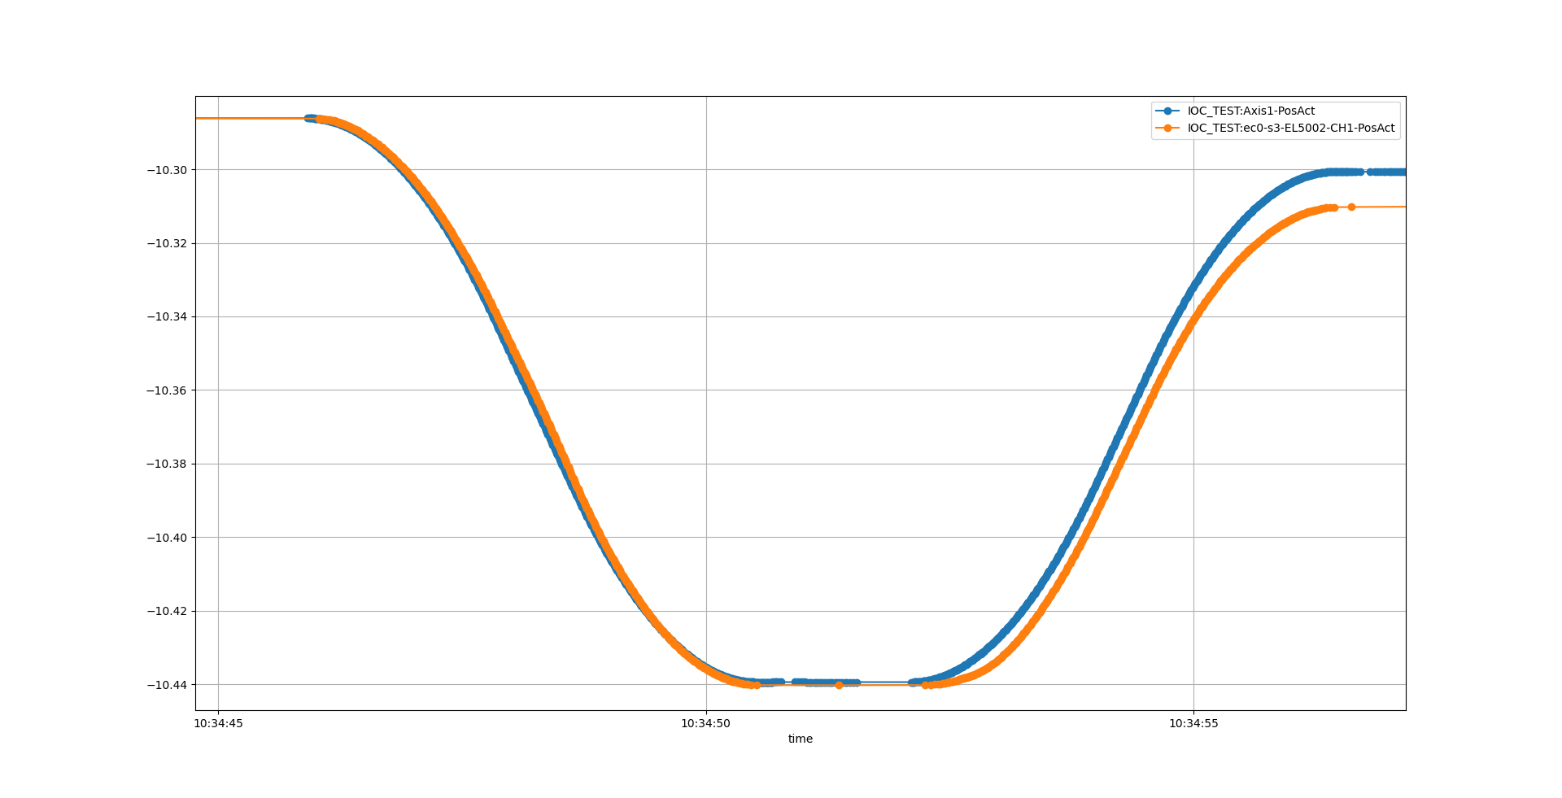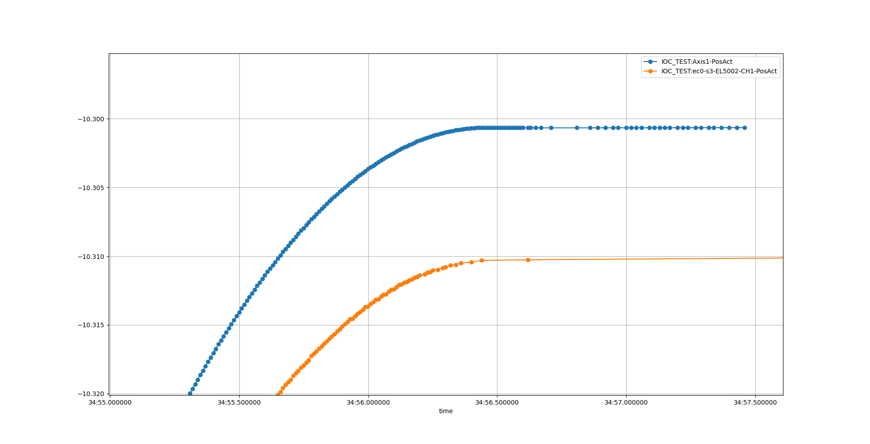

o Motor open loop position

o Encoder position

Tank angle

Time

Figure 3: Backlash test in forward direction

Both tests indicate a backlash of 0.01deg between motor and encoder.

## Motion range and switch performance

### Motion range

During the motion range test, when approaching the upper hard limit, the tank collided with the center concrete block, Figure 4.

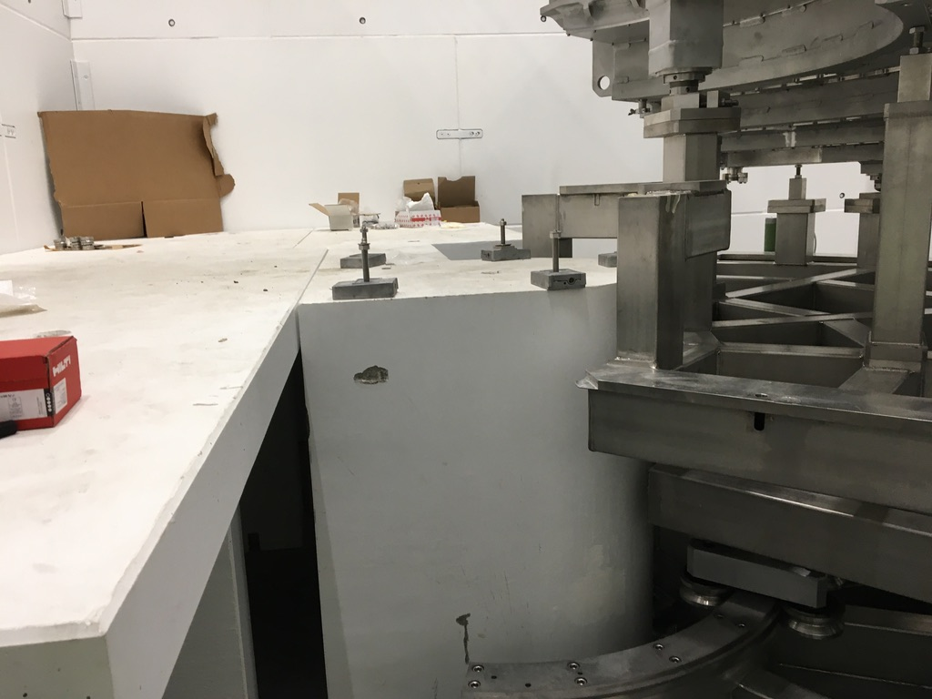

Figure 4: Collision with center concrete block.

After the collision, the CAD drawings were checked and there it was clear that it would not be possible to reach the hard stop, Figure 5, unfortunately this was not realized before it happened.



Figure 5: CAD drawing of tank in hard stop position (from above)

As can be seen in the cad drawing, the edge of the upper tank frame collides with the concrete block and after analysis it was concluded that both the concrete block and the tank frame was displaced.

An analysis of the motion performance differences before and after the collision can be found in chapter 6.

## High speed test

No problem was encountered when running in 0.1 deg/s. The whole stroke was measured and the encoder and motor position follow like expected, see Figure 4.

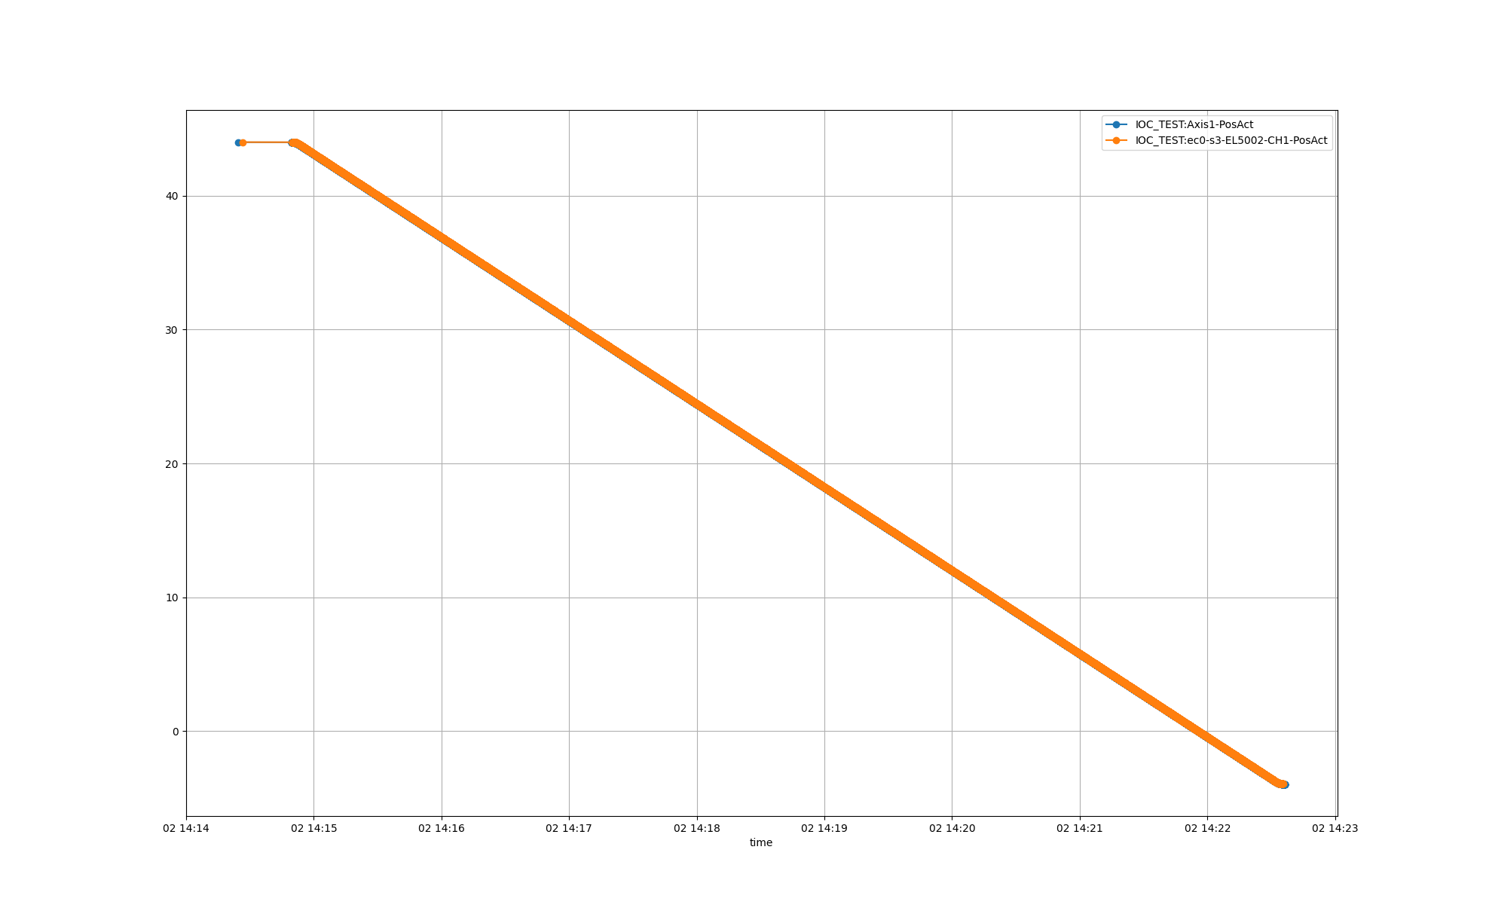

o Motor open loop position

o Encoder position

Tank angle

Time

Figure 6: High speed test over entire stroke (backward direction)

By removing the linear component of the encoder position data the error of encoder position versus the motor position can be analyzed, see Figure 5.

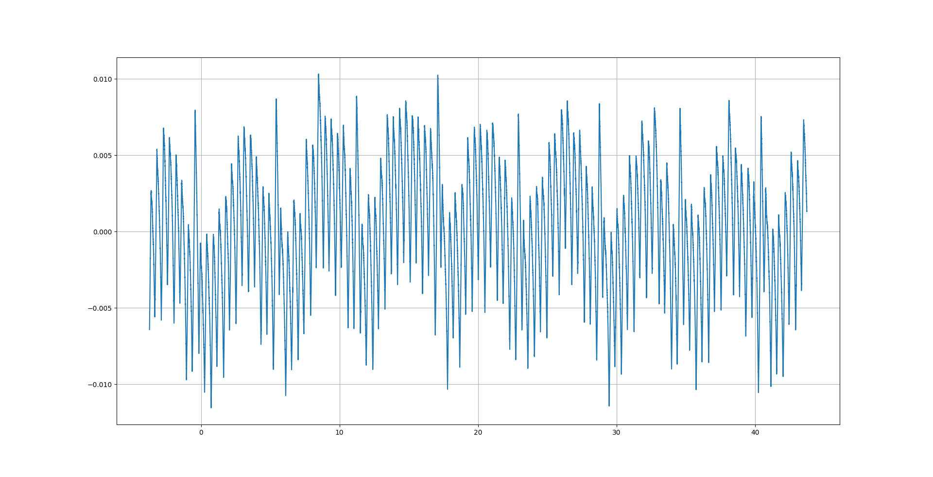

Tank angle

Figure 7: Encoder error vs tank angle (without backlash)

The data shows a repeated oscillation each 5-6 degrees in the position error between the motor position and encoder position. Also, a shorter wavelength disturbance can be identified, Figure 6. The source of these errors can probably be found in the mechanical design, like frame design and motion system (gears and chains).

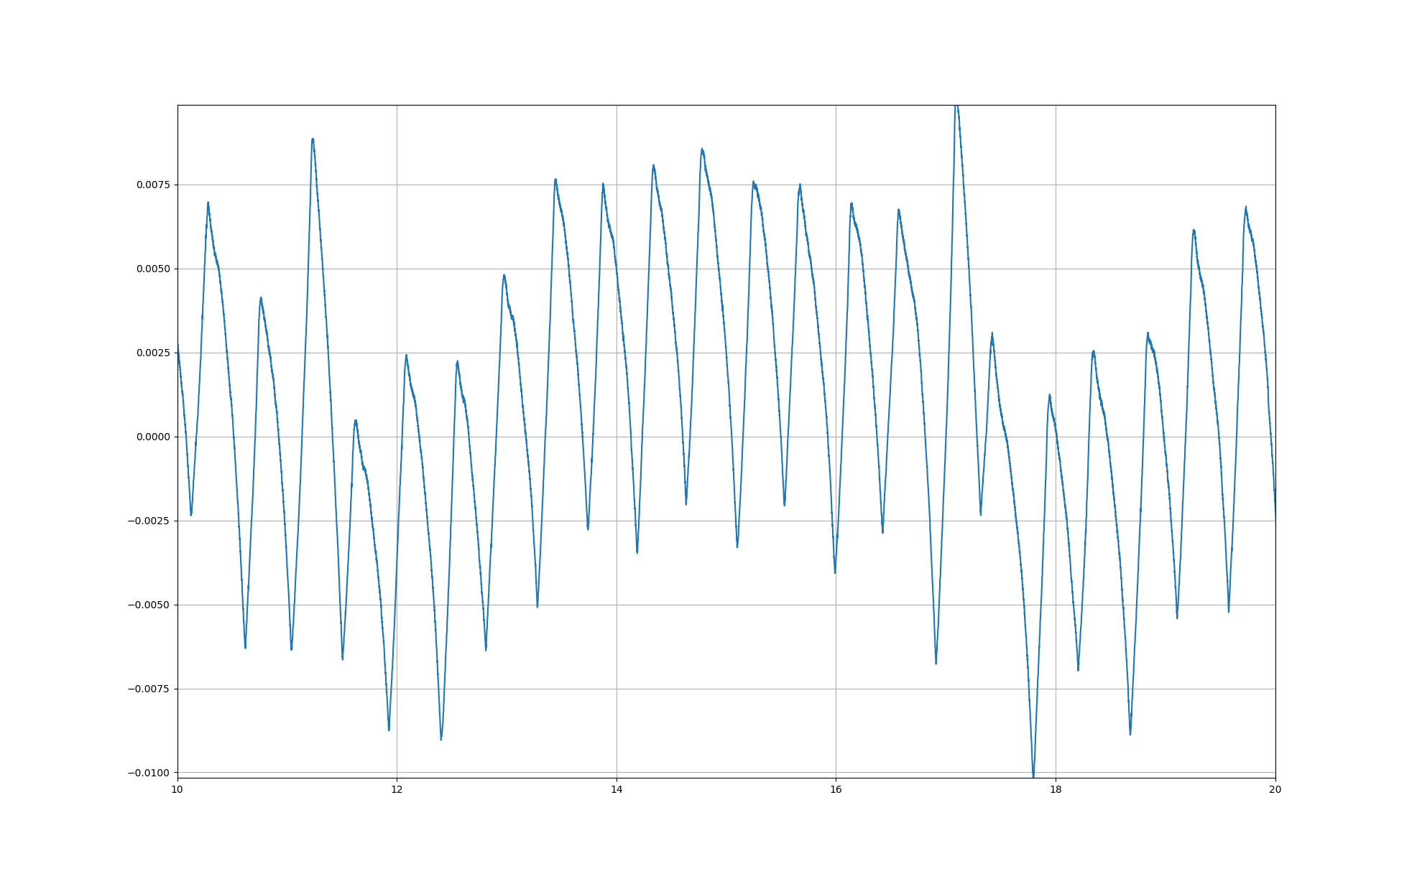

Figure 8: Encoder error vs tank angle, zoom 10..20 deg (without backlash)

Both these disturbances will lead to a maximum error over the stroke of +-0.01 degrees between the motor position and the encoder position.

## Accuracy

Table 3, shows the data collected during the accuracy test.

Table 3: Accuracy test data

|  |  |  |  |  |  |
| --- | --- | --- | --- | --- | --- |
| **Position** | **Laser tracker position [deg]** | **Open loop position [deg]** | **Open loop diff abs [deg]** | **Encoder [deg]** | **Encoder Diff abs [deg]** |
| hardstop low | -10,98 | -10,97821038 | 0,001789625 | -10,97441724 | 0,005582764 |
| -5 | -5,0177 | -5,0097 | 0,0080 | -5,0102 | 0,0075 |
| 0 | 0,0192 | -0,0081 | 0,0273 | -0,0117 | 0,0309 |
| 5 | 4,9862 | 4,9934 | 0,0072 | 4,9956 | 0,0094 |
| 10 | 9,9888 | 9,9949 | 0,0061 | 9,9986 | 0,0098 |
| 15 | 14,9897 | 14,9964 | 0,0067 | 15,0016 | 0,0119 |
| 20 | 19,9951 | 19,9980 | 0,0029 | 19,9979 | 0,0028 |
| 25 | 24,9998 | 24,9995 | 0,0003 | 24,9971 | 0,0027 |
| 30 | 29,9965 | 30,0010 | 0,0045 | 29,9951 | 0,0014 |
| 35 | 35,0005 | 35,0025 | 0,0020 | 34,9974 | 0,0031 |
| 40 | 40,0095 | 40,0041 | 0,0054 | 40,0049 | 0,0046 |
| 45 | 45,0127 | 45,0056 | 0,0071 | 45,0114 | 0,0013 |
| hardstop high | 48,5000 |  |  |  |  |

From the data the optimal gear ratio and accuracy can be calculated, see Table 4.

Table 4: Accuracy

|  |  |  |  |
| --- | --- | --- | --- |
| **Source** | **Gear ratio []** | **Offset [deg]** | **Accuracy [deg]** |
| **Openloop position** | 8,10412E-05 degtank/degmotor | -0,0081 | 0,0273 |
| **Posital position** | -4,45114E-05 degtank/encoder count | 30,7267 | 0,0309 |

Note: Since only one data point per target position was measured, the maximum deviation from target position is considered to be the accuracy.

In Table 3, the value at 0 degrees is clearly standing out with high deviation. If the values at zero is considered as an outlier and thereby excluded the updated accuracy values can be found in Table 5 and Table 6.

Table 5: Accuracy test data with position zero excluded

|  |  |  |  |  |  |
| --- | --- | --- | --- | --- | --- |
| **Position** | **Laser tracker [deg]** | **Open loop position [deg]** | **Open loop diff abs [deg]** | **Encoder [deg]** | **Encoder Diff abs [deg]** |
| hardstop low |  |  |  |  |  |
| -5 | -5,0177 | -5,0194 | 0,0017 | -5,02125 | 0,0036 |
| 0 | Excluded | Excluded | Excluded | Excluded | Excluded |
| 5 | 4,9862 | 4,9862 | 0,0000 | 4,9875 | 0,0013 |
| 10 | 9,9888 | 9,9890 | 0,0002 | 9,9920 | 0,0032 |
| 15 | 14,9897 | 14,9919 | 0,0022 | 14,9964 | 0,0067 |
| 20 | 19,9951 | 19,9947 | 0,0004 | 19,9942 | 0,0009 |
| 25 | 24,9998 | 24,9975 | 0,0023 | 24,9949 | 0,0049 |
| 30 | 29,9965 | 30,0004 | 0,0039 | 29,9944 | 0,0021 |
| 35 | 35,0005 | 35,0032 | 0,0027 | 34,9981 | 0,0024 |
| 40 | 40,0095 | 40,0060 | 0,0035 | 40,0071 | 0,0024 |
| 45 | 45,0127 | 45,0089 | 0,0038 | 45,0150 | 0,0023 |
| hardstop high | 48,5000 |  |  |  |  |

Table 6: Accuracy with position 0 excluded

|  |  |  |  |
| --- | --- | --- | --- |
|  | **Gear ratio** | **Offset [deg]** | **Accuracy [deg]** |
| **Openloop** | 8,1062E-05 | -0,0166 | 0,0039 |
| **Posital** | -4,4525E-05 | 30,7262 | 0,0067 |

## Bidirectional repeatability

Date acquired during the repeatability test are listed in chapter 9 Appendix: Repeatability data. Based on these data sets the repeatability can be calculated to be 0.010 degress.

# Differences before and after collision

In order to judge if the collision have impacted the performance of the motion system some comparisons can be made by looking at data collected before and after. Unfortunately, only a few comparable datasets have been identified but in total three comparisons can be made based on the recorded data:

1. Backlash
2. Encoder error (vs linear open loop counter)
3. Accuracy and gear ratio

## Backlash

From the data acquired during the high-speed tests also backlash in one direction can be checked. Figure 5 shows motor open loop counter and encoder position during the acceleration phase.

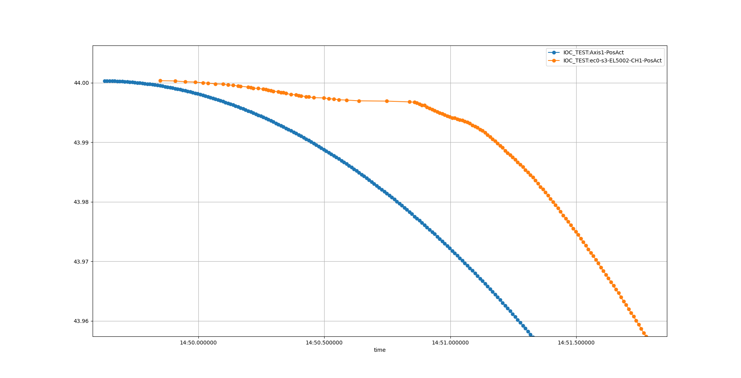

Time

Tank angle

o Motor open loop position

o Encoder position

Figure 9: Backlash after collision

For this move the backlash seems to be approx. 0.02deg compared to 0.01deg before. Another thing worth noting is the behavior of the encoder position curve where the value seems to update unpredictable in the acceleration phase

Note: Before the collision, no data was recorded at this tank angle. Therefore, it’s hard to judge if the increase in backlash is related to the collision.

## Motor position vs encoder position

Data for open loop counter position and encoder position was acquired for angles between 9 and 23 degrees both before and after collision. Unfortunately, the velocity was different at the two tests:

* before collision 688degmotor/s
* after collision 1280degmotor/s

Figure 6 shows the deviation of the encoder position from the motor open loop position at angles between 9 to 23 degrees (at a velocity of 688degmotor/s). Figure 7 shows the same data but acquired after the collision but at a higher velocity (1280degmotor/s). In both graphs the backlash is not shown.

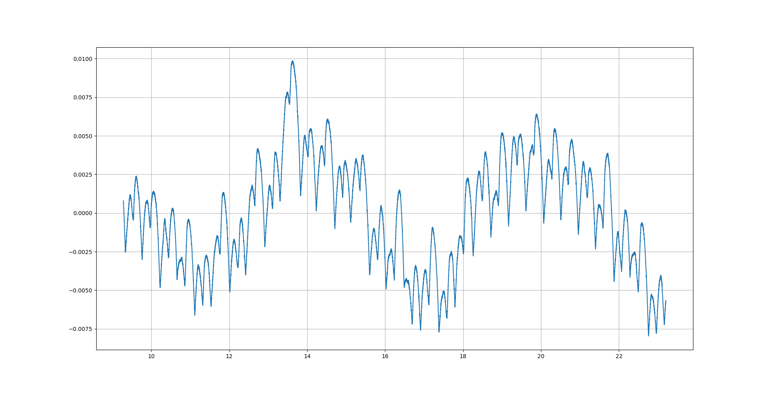

Figure 10: Before collision: Encoder position error (without backlash) at 688degmotor/s

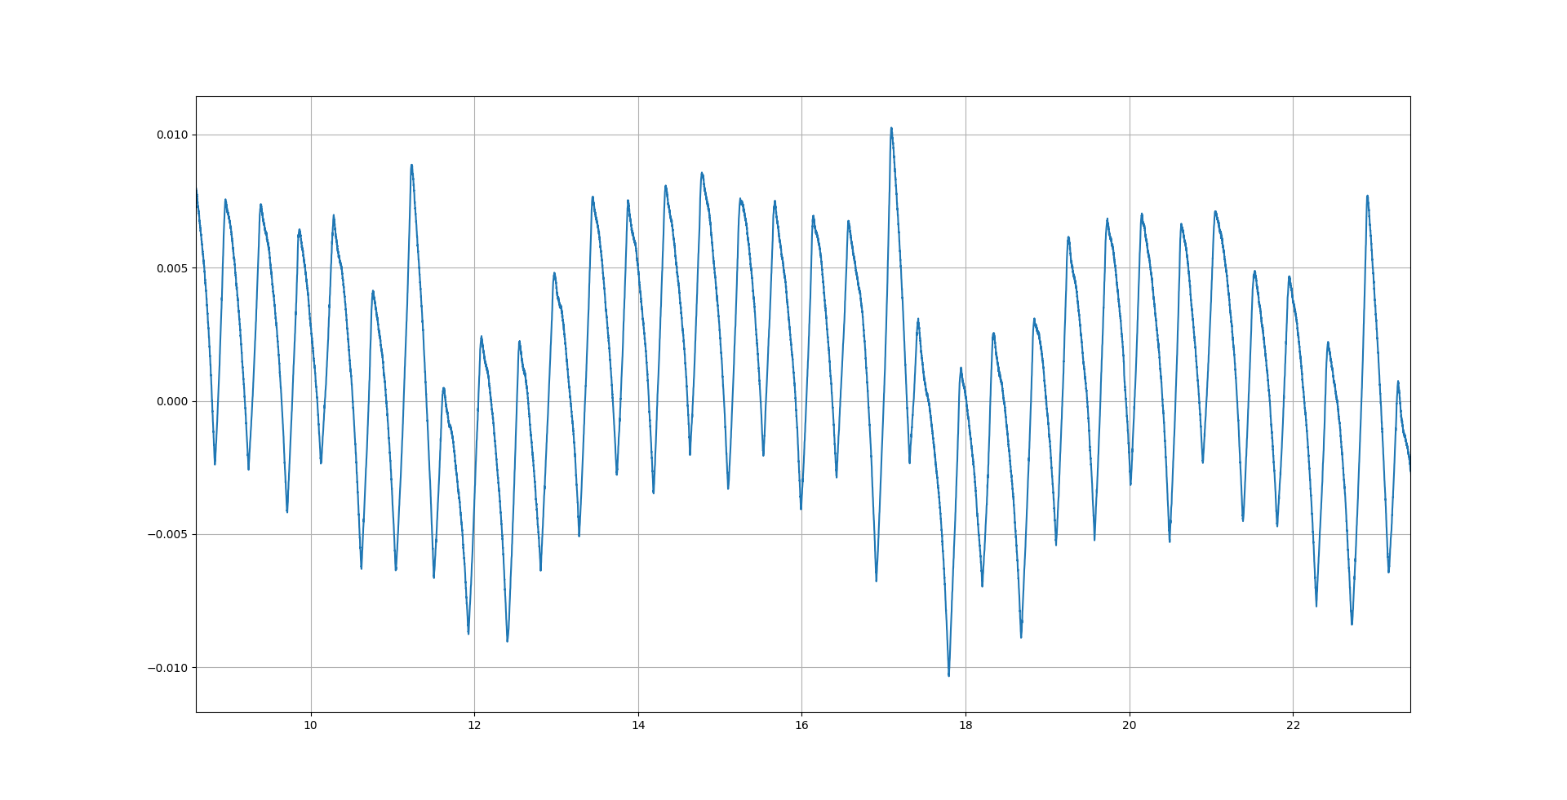

Figure 11: After collision: Encoder position error (without backlash) at 1280degmotor/s

The same cyclic error with a frequency of approx. 6 degrees and an amplitude 0.01deg can be identified in both graphs. However, the amplitude of the lower wavelength frequency error has increased after the collision.

## Accuracy and gear ratio

A reduced accuracy test was performed also after the collision. In this test not at all the positions that were measured in the original accuracy tests was included, Table 5.

Table 7: After collision: Accuracy measurements

|  |  |  |  |  |  |
| --- | --- | --- | --- | --- | --- |
| **Position** | **Laser tracker [deg]** | **Open loop position [deg]** | **Open loop diff abs [deg]** | **Posital Encoder [deg]** | **Posital Diff abs [deg]** |
| hardstop low | 10.98 |  |  |  |  |
| -5 | -5,0017 | -5,0112 | 0,0095 | -5,0043 | 0,0026 |
| 0 | 0,0000 | -0,0119 | 0,0119 | 0,0009 | 0,0009 |
| 5 | 4,9725 | 4,9873 | 0,0148 | 4,9734 | 0,0009 |
| 10 | 9,9755 | 9,9866 | 0,0111 | 9,9781 | 0,0026 |
| 15 |  |  | 0,0000 |  | 0,0000 |
| 20 |  |  | 0,0000 |  | 0,0000 |
| 25 |  |  | 0,0000 |  | 0,0000 |
| 30 |  |  | 0,0000 |  | 0,0000 |
| 35 | 34,9801 | 34,9830 | 0,0029 | 34,9763 | 0,0038 |
| 40 |  |  | 0,0000 |  | 0,0000 |
| 45 | 44,9890 | 44,9815 | 0,0075 | 44,9909 | 0,0019 |
| hardstop high |  |  | 0,0000 |  | 0,0000 |

The calculated accuracy based on these data are shown in Table 6 and can be compared with the accuracies calculated based on the data from before collision, Table 7.

Table 8: After collision: Accuracy and gear ratio

|  |  |  |  |
| --- | --- | --- | --- |
| **Source** | **Gear ratio** | **Offset [deg]** | **Accuracy [deg]** |
| **Open loop motor** | 8,10047E-05 | -0,2793 | 0,0148 |
| **Encoder** | -4,45181E-05 | 30,7399 | 0,0038 |

Table 9: Before collision: Accuracy and gear ratio

|  |  |  |  |
| --- | --- | --- | --- |
| **Source** | **Gear ratio** | **Offset [deg]** | **Accuracy [deg]** |
| **Open loop motor** | 8,10412E-05 | -0,0081 | 0,0273 |
| **Encoder** | -4,45114E-05 | 30,7267 | 0,0309 |

Both motor open loop position accuracy and encoder position accuracy have improved slightly after the collision. One explanation for this could be that the first accuracy measurement was including more points and therefore higher value could be expected. Worth noting is that the optimal gear ratio has changed slightly which also could be related to the different number of measurement points included in the two tests.

# CONCLUSIONS

# references

1. EtherCAT organization, <https://www.ethercat.org>
2. ecmc, open source motion control, <https://accelconf.web.cern.ch/icalepcs2017/talks/mocpl05_talk.pdf>
3. Control system configurations and raw data, <https://github.com/anderssandstrom/ecmc_bifrost_slits_sat/>
4. EL7037, <https://www.beckhoff.com/english.asp?ethercat/el7037.htm>
5. EL1808, <https://www.beckhoff.com/english.asp?ethercat/el1808.htm>
6. EL2808, <https://www.beckhoff.com/english.asp?ethercat/el2808.htm>
7. EL7201, <https://www.beckhoff.com/english.asp?ethercat/el7201.htm>
8. AML 42.3 Stepper motor, <https://arunmicro.com/products/D42-3_UHV_Compatible_Stepper_Motor/>
9. Micro-Epsilon laser triangulation sensor, <https://www.micro-epsilon.com/displacement-position-sensors/laser-sensor/optoNCDT_2300_basic/>
10. AMCI r11 Resolver, <https://www.amci.com/plc-automation-products/r11-size-11-brushless-resolver-sensors>
11. Bifrost Divergence Slits DTU Physics Test Plan 18032, Revision 4 of Oct 27th, 2020

Document Revision history

| Revision | Reason for and description of change | Author | Date |
| --- | --- | --- | --- |
| 1 | First issue | Anders Sandström | 2020-12-17 |
|  |  |  |  |
|  |  |  |  |

# Appendix: Switch perfromance

|  |  |  |  |  |
| --- | --- | --- | --- | --- |
| Low Kill Switch | Posital encoder |  |  |  |
| L1 | Engage | Disengage | Engage range | Disengage Range |
| 1 | -4,606081958 | -4,573677657 | 0,000712182 | 0,00031158 |
| 2 | -4,605681355 | -4,573855703 |  |  |
| 3 | -4,605859401 | -4,573855703 |  |  |
| 4 | -4,606393537 | -4,573811191 |  |  |
| 5 | -4,605903912 | -4,573989237 |  |  |
|  |  |  |  |  |
|  |  |  |  |  |
| Low Limit Switch | Posital encoder |  |  |  |
| L2 | Engage | Disengage | Engage range | Disengage Range |
| 1 | -4,280436542 | -4,252973007 | 0,000845716 | 0,000756694 |
| 2 | -4,281282258 | -4,253329098 |  |  |
| 3 | -4,280970678 | -4,253729701 |  |  |
| 4 | -4,281104213 | -4,253551655 |  |  |
| 5 | -4,281104213 | -4,253729701 |  |  |
|  |  |  |  |  |
|  |  |  |  |  |
| Anticollision Switch | Posital encoder |  |  |  |
| L3 | Engage | Disengage | Engage range | Disengage Range |
| 1 | 32,86241426 | 32,83125629 | 0,00031158 | 0,000356091 |
| 2 | 32,86272584 | 32,8309002 |  |  |
| 3 | 32,86259231 | 32,83103373 |  |  |
| 4 | 32,8625478 | 32,83107824 |  |  |
| 5 | 32,86259231 | 32,83103373 |  |  |
|  |  |  |  |  |
|  |  |  |  |  |
| High Limit Switch | Posital encoder |  |  |  |
| L4 | Engage | Disengage | Engage range | Disengage Range |
| 1 | 44,96484186 | 44,92268956 | 0,0004006 | 0,000400602 |
| 2 | 44,96519795 | 44,92264505 |  |  |
| 3 | 44,96484186 | 44,92228896 |  |  |
| 4 | 44,96524246 | 44,92251152 |  |  |
| 5 | 44,96488637 | 44,92251152 |  |  |
|  |  |  |  |  |
|  |  |  |  |  |
| Switch | Posital encoder |  |  |  |
| L5 | Engage | Disengage | Engage range | Disengage Range |
| 1 | 45,34999902 | 45,32097758 | 0,00031158 | 0,00035609 |
| 2 | 45,34982098 | 45,32133367 |  |  |
| 3 | 45,34999902 | 45,32128916 |  |  |
| 4 | 45,34995451 | 45,32097758 |  |  |
| 5 | 45,35013256 | 45,32111112 |  |  |

# Appendix: Repeatability data

|  |  |  |  |
| --- | --- | --- | --- |
| **Position** | **-5deg** | **from below** |  |
| Test | Laser Scanner | Open loop counter | Posital encoder |
| 1 | -5,0168 | -5,009677375 | -5,01002292 |
| 2 | -5,0185 | -5,009676806 | -5,01020097 |
| 3 | -5,0184 | -5,009677375 | -5,01042353 |
| 4 | -5,0197 | -5,009676806 | -5,01091315 |
| 5 | -5,0196 | -5,009677375 | -5,01055706 |
| 6 | -5,0196 | -5,009677375 | -5,01077962 |
| Range | 0,00290 | 0,00000057 | 0,00089 |
| STD | 0,001125463 | 2,94192E-07 | 0,0003386 |
| Repeatabilty | 0,00290 |  |  |
|  |  |  |  |
| **Position** | **-5deg** | **from above** |  |
| Test | Laser Scanner | Open loop counter | Posital encoder |
| 1 | -5,0073 | -5,00966996 | -4,9966695 |
| 2 | -5,0064 | -5,00966996 | -4,99707011 |
| 3 | -5,0065 | -5,00966996 | -4,99684755 |
| 4 | -5,006 | -5,00966996 | -4,99671401 |
| 5 | -5,0062 | -5,00966996 | -4,99653597 |
| 6 | -5,0044 | -5,00966996 | -4,99649146 |
| Range | 0,00290 | 0,00000000 | 0,00058 |
| STD | 0,000958471 | 0 | 0,000213315 |
| Repeatabilty | 0,00290 |  |  |

|  |  |  |  |
| --- | --- | --- | --- |
|  |  |  |  |
| **Position** | **0deg** | **from below** |  |
| Test | Laser Scanner | Open loop counter | Posital encoder |
| 1 | 0,0173 | -0,008148729 | -0,010012653 |
| 2 | 0,0171 | -0,008149299 | -0,010324233 |
| 3 | 0,0173 | -0,008149299 | -0,010190699 |
| 4 | 0,0166 | -0,008149299 | -0,010680324 |
| 5 | 0,0164 | -0,008149299 | -0,010502279 |
| 6 | 0,017 | -0,008148729 | -0,01085837 |
| Range | 0,00090 | 0,00000057 | 0,00085 |
| STD | 0,000372827 | 2,94295E-07 | 0,000314323 |
| Repeatabilty | 0,00090 |  |  |
|  |  |  |  |
| **Position** | **0deg** | **from above** |  |
| Test | Laser Scanner | Open loop counter | Posital encoder |
| 1 | 0,0006 | -0,008141321 | 0,007079725 |
| 2 | 0,0015 | -0,00814189 | 0,005877917 |
| 3 | 0,0011 | -0,008141321 | 0,006367542 |
| 4 | 0,0001 | -0,00814189 | 0,006412054 |
| 5 | 0,0002 | -0,00814189 | 0,0065901 |
| 6 | 0,001 | -0,008141321 | 0,006768145 |
| Range | 0,00140 | 0,00000057 | 0,00120 |
| STD | 0,000546809 | 3,11654E-07 | 0,000406657 |
| Repeatabilty | 0,00140 |  |  |

|  |  |  |  |
| --- | --- | --- | --- |
|  |  |  |  |
| **Position** | **10deg** | **from below** |  |
| Test | Laser Scanner | Open loop counter | Posital encoder |
| 1 | 9,9904 | 9,994907425 | 9,99935529 |
| 2 | 9,99 | 9,994907425 | 9,99904371 |
| 3 | 9,9896 | 9,994907425 | 9,99882115 |
| 4 | 9,9987 | 9,994907425 | 9,99850957 |
| 5 | 9,989 | 9,994907992 | 9,99846506 |
| 6 | 9,9886 | 9,994907425 | 9,99828701 |
| Range | 0,01010 | 0,00000057 | 0,00107 |
| STD | 0,003804077 | 2,31477E-07 | 0,000402742 |
| Repeatabilty | 0,01010 |  |  |
|  |  |  |  |
| **Position** | **10deg** | **from above** |  |
| Test | Laser Scanner | Open loop counter | Posital encoder |
| 1 | 10,0046 | 9,994914832 | 10,01524586 |
| 2 | 10,0047 | 9,994914832 | 10,01435563 |
| 3 | 10,0051 | 9,994914832 | 10,01466721 |
| 4 | 10,0046 | 9,994914832 | 10,01484526 |
| 5 | 10,0048 | 9,994914265 | 10,0150233 |
| 6 | 10,0054 | 9,994914832 | 10,01520135 |
| Range | 0,00080 | 0,00000057 | 0,00089 |
| STD | 0,000320416 | 2,31477E-07 | 0,000340156 |
| Repeatabilty | 0,00089 |  |  |

|  |  |  |  |
| --- | --- | --- | --- |
|  |  |  |  |
| **Position** | **20deg** | **from below** |  |
| Test | Laser Scanner | Open loop counter | Posital encoder |
| 1 | 19,9969 | 19,9979635 | 19,99910877 |
| 2 | 19,9954 | 19,9979635 | 19,99861914 |
| 3 | 19,9948 | 19,9979635 | 19,9984411 |
| 4 | 19,9948 | 19,9979635 | 19,99826305 |
| 5 | 19,995 | 19,9979635 | 19,9980405 |
| 6 | 19,9949 | 19,9979635 | 19,99790696 |
| Range | 0,00210 | 0,00000000 | 0,00120 |
| STD | 0,000814862 | 0 | 0,0004343 |
| Repeatabilty | 0,00210 |  |  |
|  |  |  |  |
| **Position** | **20deg** | **from above** |  |
| Test | Laser Scanner | Open loop counter | Posital encoder |
| 1 | 20,016 | 19,99797098 | 20,0129963 |
| 2 | 20,011 | 19,99797098 | 20,0132188 |
| 3 | 20,0113 | 19,99797098 | 20,0133969 |
| 4 | 20,0117 | 19,99797098 | 20,0135749 |
| 5 | 20,0114 | 19,99797098 | 20,013753 |
| 6 | 20,0115 | 19,99797098 | 20,0130408 |
| Range | 0,00500 | 0,00000000 | 0,00076 |
| STD | 0,001900263 | 0 | 0,000300246 |
| Repeatabilty | 0,00500 |  |  |

|  |  |  |  |
| --- | --- | --- | --- |
|  |  |  |  |
| **Position** | **30deg** | **from below** |  |
| Test | Laser Scanner | Open loop counter | Posital encoder |
| 1 | 29,9964 | 30,0010203 | 29,99623608 |
| 2 | 29,9968 | 30,00101974 | 29,99659217 |
| 3 | 29,9974 | 30,0010203 | 29,99641413 |
| 4 | 29,9969 | 30,00101974 | 29,99623608 |
| 5 | 29,9963 | 30,00101974 | 29,99605803 |
| 6 | 29,9964 | 30,00101974 | 29,99601352 |
| Range | 0,00110 | 0,00000057 | 0,00058 |
| STD | 0,000419524 | 2,92798E-07 | 0,000217607 |
| Repeatabilty | 0,00110 |  |  |
|  |  |  |  |
| **Position** | **30deg** | **from above** |  |
| Test | Laser Scanner | Open loop counter | Posital encoder |
| 1 | 30,0162 | 30,00102771 | 30,0163107 |
| 2 | 30,0168 | 30,00102714 | 30,0166668 |
| 3 | 30,0167 | 30,00102714 | 30,0168893 |
| 4 | 30,0167 | 30,00102714 | 30,0172009 |
| 5 | 30,017 | 30,00102771 | 30,017379 |
| 6 | 30,0174 | 30,00102771 | 30,0176015 |
| Range | 0,00120 | 0,00000057 | 0,00129 |
| STD | 0,000394968 | 3,12202E-07 | 0,000478294 |
| Repeatabilty | 0,00129 |  |  |

|  |  |  |  |
| --- | --- | --- | --- |
|  |  |  |  |
| **Position** | **40deg** | **from below** |  |
| Test | Laser Scanner | Open loop counter | Posital encoder |
| 1 | 40,0132 | 40,00407645 | 40,0059156 |
| 2 | 40,0078 | 40,00407645 | 40,0066723 |
| 3 | 40,0078 | 40,00407702 | 40,0064942 |
| 4 | 40,0044 | 40,00407645 | 40,0063162 |
| 5 | 40,0069 | 40,00407702 | 40,0060936 |
| 6 | 40,0055 | 40,00407702 | 40,0059601 |
| Range | 0,00880 | 0,00000057 | 0,00076 |
| STD | 0,003052212 | 3,12202E-07 | 0,000304071 |
| Repeatabilty | 0,00880 |  |  |
|  |  |  |  |
| **Position** | **40deg** | **from above** |  |
| Test | Laser Scanner | Open loop counter | Posital encoder |
| 1 | 40,0172 | 40,00408386 | 40,01931354 |
| 2 | 40,0221 | 40,00408386 | 40,01949158 |
| 3 | 40,0176 | 40,00408329 | 40,01966963 |
| 4 | 40,0224 | 40,00408386 | 40,01984767 |
| 5 | 40,0186 | 40,00408386 | 40,01998121 |
| 6 | 40,0249 | 40,00408386 | 40,02015925 |
| Range | 0,00770 | 0,00000057 | 0,00085 |
| STD | 0,003112341 | 2,32702E-07 | 0,000314322 |
| Repeatabilty | 0,00770 |  |  |